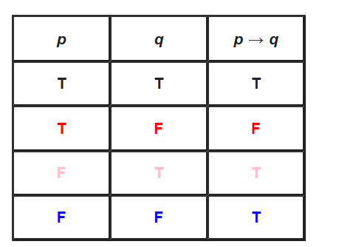 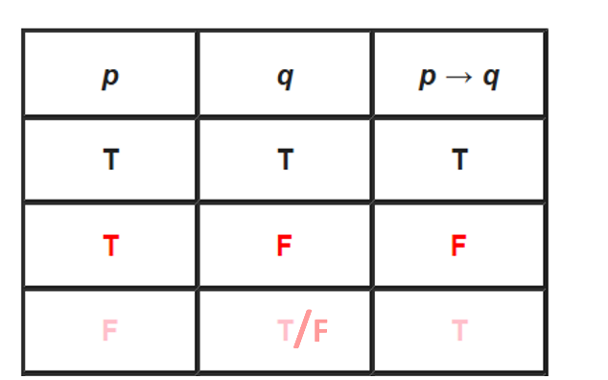

Modus ponens

p--->q and p are given, based on what q is derived.

Suppose p--->q: If it rained then street is wet. p: It rained. q: Street is wet.

**(1) For the 1st row, if p--->q is TRUE, given p true, q is also true.**

Eg.

If it rained then street is wet (p--->q is TURE),

And we know that it rained(p is TRUE),

then we can say that street is wet(q is also TRUE).

**(2) For the 2nd row, given p--->q is FALSE which means p--->~q is TRUE. Now p is TRUE, then we can get ~q is TRUE, which means q is FALSE.**

Eg.

If it rained, then the street is not wet. (p--->~q is TRUE because p--->q is FALSE)

So now it rained (p is TRUE), then the street is not wet. (~q is TRUE, q is FALSE).

**(3) For the 3rd and 4th rows which could combined together for better understanding, if p--->q is TRUE and p is FALSE, then q could be FALSE or TRUE. Which means you can not get the right derivation from what is the given(p is FALSE).**

Eg.

If it rained, then the street is wet (p--->q is TRUE). If it didn’t rain, we don’t know the results of the street(could be wet q or not wet ~q).

Given that it didn’t rain (p is FALSE), then we don’t know whether the street is wet or not (q could be either FALSE or TRUE).